Slide 1  Reciprocal Teaching  Title Slide  Materials:  Facilitator Guidebook  For RT Workshop  RT Power point Presentation  Vocational /Technical Textbook or reading samples.  Facilitator Readings:  Before the workshop read the short research brief: Reciprocal Teaching, pages 144-148, from Michael C. McKenna’s book:  Help for Struggling Readers: Strategies for Grades 3-8. Hence referred to as Handout 1-1 in this workshop guide. | 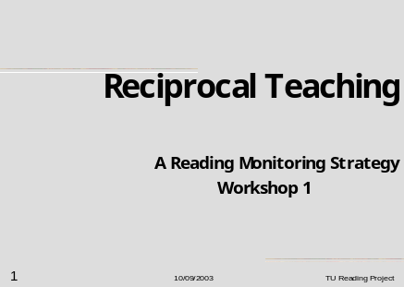  Facilitator Instructions:  - Display this slide.  - Present and discuss the six objectives of the workshop.  - Ask teachers to locate a difficult passage in their vocational/technical textbook. Scan this passage silently while they consider the following two questions.  - Question 1: Why the passage they have scanned is difficult to read?  - Question 2: What reading problems they are observing with struggling readers in their classroom.  - Ask teachers to take note of these problems as they view the workshop presentation, as see if they are addressed, either in the information given or during discussion activities with their peers. | Participant Instructions:  1. Read Slide 1 and note the following ideas:  Participants should be informed about the six workshop objectives that will be addressed in this workshop.  This workshop will address the six learning objectives below:  - Teachers will be given a definition of reciprocal teaching.  - Teachers will analyze four reciprocal teaching strategies of predicting, clarifying, questioning, and summarizing.  - Teachers will discuss implementation techniques for using reciprocal teaching strategy in their vocational/technical area.  - Teachers will identify student reading difficulties.  - Teachers will apply RT strategy to remediate the reading instruction to struggling readers in their classroom.  - Teachers will apply the guided practice model to integrate reading strategy in their subject area.

Slide 2  What is Reciprocal Teaching?  Materials:  Guidebook For RT  RT Power point Presentation  Vocational /Technical Textbook.  Handout 2-1.  The Strategic Reader (McEwan, 2001).  Facilitator Readings:  Before the workshop read the short research brief: Reciprocal Teaching, pages 144-148, from Michael C. McKenna’s book:  Help for Struggling Readers: Strategies for Grades 3-8. Hence referred to as Handout 1-1 in this workshop guide. |  |  | 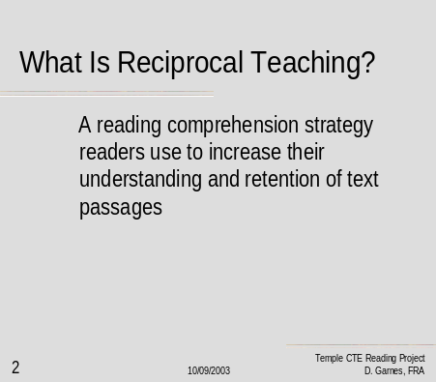  Facilitator Instructions:  - Display and Read the above slide.  - Explain that RT is not the only strategy used by strategic readers to increase their understanding and retention to text.  - Distribute and Discuss The Strategic Reader (McEwan, 2001). Strategic readers use the following strategies while they read: (Handout, Slide 2-1)  4. Explain a working definition for Reciprocal Teaching-- a reading comprehension strategy which students can use to self-monitor their understanding of the text. Students use RT strategies before, during and after the reading process to gain meaning and increase retention. But, there more advantages…go to next slide. |  | Participant Instructions:  1. Read slide 2 and note:  Discuss this question: How do strategic readers gain meaning?  Share with the workshop group how your students gain meaning from reading activities in your classroom.  Do your students do the following:  Before Reading Activities:  - Determine Purpose  - Preview and Predict  - Activate Prior Knowledge  - Ask Questions  During Reading Activities:  - Self-question  - Infer  - Develop sensory images  - Monitor and Adjust Comprehension  After Reading Activities:  - Paraphrase, retell, summarize  - Organize graphically  - Generate questions to test memory  - Evaluate ideas
Slide 3  Reciprocal Teaching  Slide: What advantages does RT offer?  Materials:  Facilitator Guidebook  For RT Workshop  RT Power point Presentation  Vocational /Technical Textbook or reading samples.  Facilitator Readings: information for discussion of this slide taken from:  the short research brief: Reciprocal Teaching, pages 144-148, from Michael C. McKenna’s book:  Help for Struggling Readers: Strategies for Grades 3-8.  Handout 1-1 | 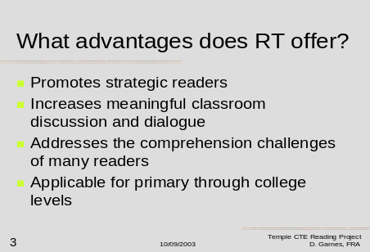  Facilitator Instructions:  - Display and Read the above slide.  2. Explain that Reciprocal Teaching  can offer many advantages in building both vocabulary and comprehension skills when reading new selections from their textbook or vocational manuals.  - Explain that reciprocal teaching is not a new technique; it was developed in 1986 for students who lack reading strategies when asked to comprehend non-fiction material.  - RT promotes strategic readers because we ask readers to become aware of the reading strategies they will use to comprehend the text they are asked to read.  - Ask teachers to recognize that increased student discussion of the material is a product of using the RT strategy.  - Facilitator’s may wish to comment on common reading challenges for students. |  |  |  |  |  |  | Participant Instructions:  - Read the slide 3 and note the following ideas.  2. Reciprocal Teaching  can offer many advantages in building both vocabulary and comprehension skills when reading new selections from their textbook or vocational manuals.  3. Reciprocal teaching is not a new technique, it was developed in 1986 for students who lack reading strategies when asked to comprehend non-fiction material.  - RT promotes strategic readers because it asks readers to become aware of the reading strategies they will use to comprehend the text they are asked to read.  - Recognize that we as adults have been taught to read so long ago that the process is automatic in our lives, but struggling readers view reading as a difficult task.  Five COMMON Reading Challenges may include:  - Troublesome vocabulary  - Failure to locate main ideas  - Difficulty in sequencing steps to a process  - Difficulty in learning career –related terminology  - Lack of comprehension after reading the selection
Slide 4  What are the RT Strategies?  Materials:  Facilitator Guidebook  For RT Workshop  RT Power point Presentation  Vocational /Technical Textbook or reading samples.  Facilitator Readings:  information for discussion of this slide taken from:  the short research brief: Reciprocal Teaching, pages 144-148, from Michael C. McKenna’s book:  Help for Struggling Readers: Strategies for Grades 3-8.  Handout 1-1 |  |  | 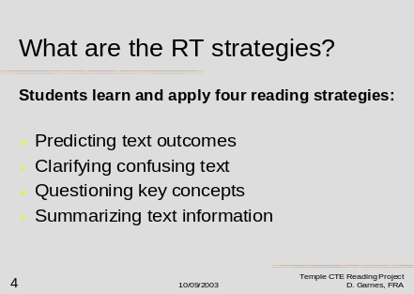  Facilitator Instructions:  - Display and Read the above slide.  - Explain that there are four stages of Reciprocal Teaching that will be discussed in detail during this workshop.  - The four RT stages briefly stated are:  - Predicting what the students will read and the outcome  - Clarifying confusing sections of the text  - Writing and asking questions about the key concepts found in the reading  - Summarizing the information read after completing the reading assignment |  | Participant Instructions:  - Read slide 4 and note the following:  - This is a key slide in the workshop because it sets the foundation for the rest of the training session. Note that many teachers may already be using these strategies in their own reading.  - Making students aware of these reading strategies can assist them to self-monitor and self-regulate how they approach their reading assignments, and make them aware of their reading tasks before, during and after reading .  - Participants may want to reflect about how they approach reading in their content areas.  - Ask: Why do teachers use Reciprocal Teaching? This is a lead in question for the next slide.
Slide 5  Why teachers use Reciprocal Teaching?  Materials:  Facilitator Guidebook  For RT Workshop  RT Power point Presentation  Vocational /Technical Textbook or reading samples.  Facilitator Readings:  information for discussion of this slide taken from:  the short research brief: Reciprocal Teaching, pages 144-148, from Michael C. McKenna’s book:  Help for Struggling Readers: Strategies for Grades 3-8.  Handout 1-1 |  |  | 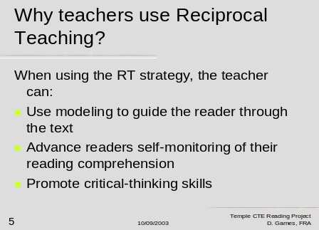  Facilitator Instructions:  1. Display and Read the above slide.  2. EXPLAIN: When using modeling, teachers assume a major responsibility for the instruction of the four strategies  for example:  - Teachers may think aloud about how they would generate a summary  - What cues they use to make predictions  - How rereading is useful in clarifying difficult passages of the text  - How reading ahead may answer some questions that students may encounter in the text  - The aim of RT is to construct meaning from the text, and to monitor the success with which comprehension is occurring.  - Teaching students to think about how they read is a critical thinking skill. |  | Participant Instructions:  - Read slide 5 and note:  - It is suggested that teachers model the RT strategies at first, so that students can be guided through the reading assignment and learn the self –monitoring and self-regulation of their reading.  Instruction using RT Strategies can help the teacher:  - Activate a student’s prior knowledge.  - Evaluate how well your students can frame questions from the text.  - Provide the teacher with diagnostic information about how well their students can comprehend new terms, locate main and supportive ideas, and understand processes and sequences.  - Encourage student discussion of the reading assignment
Slide 6  Why students use Reciprocal Teaching?  Materials:  Facilitator Guidebook  For RT Workshop  RT Power point Presentation  Vocational /Technical Textbook or reading samples.  Facilitator Readings  information for discussion of this slide taken from:  the short research brief: Reciprocal Teaching, pages 144-148, from Michael C. McKenna’s book:  Help for Struggling Readers: Strategies for Grades 3-8.  Handout 1-1 |  |  | 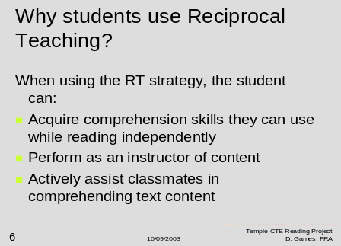  Facilitator Instructions:  - Display and Read the above slide.  - Explain that using RT strategies can help the student also.  Students can acquire comprehension skills by :  - Recalling their prior knowledge.  - Extending understanding of what they are reading.  - Prior knowledge provides an interpretative base for understanding new material.  - Students can instruct each other by asking and writing questions over the material being read.  - Students can help other classmates sharing their questions and summaries as they reprocess information they have read. |  | Participant Instructions:  - Read slide 6 and note:  Summarizing is a clear indication of whether the material has been understood.  If students are unable to summarize, it is a strong clue to the teacher to reprocess the information, they can do this with help from the students and with support guides and cues delivered in this workshop.
Slide 7  What are the components of RT?  Materials:  Facilitator Guidebook  For RT Workshop  RT Power point Presentation  Vocational /Technical Textbook or reading samples.  Facilitator Readings  information for discussion of this slide taken from:  the short research brief: Reciprocal Teaching, pages 144-148, from Michael C. McKenna’s book:  Help for Struggling Readers: Strategies for Grades 3-8.  Handout 1-1 |  |  | 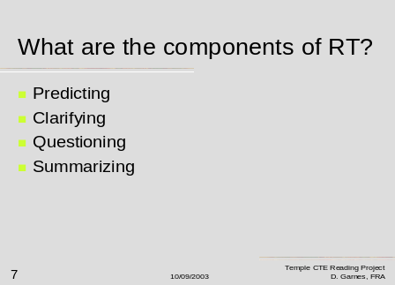  Facilitator Instructions:  - Display and Read the above slide.  - This slide is an organizational slide which leads into the four different strategies of Reciprocal Teaching.  - Explain to the group that each area will be discussed in further detail further on in the worshop  - Move onto the next slide for order of the RT strategy process of reading instruction. |  | Participant Instructions:  - Read slide 7 and note the following:  - There are four components to RT.  - Each component may be used separately or in combination with a reading lesson.  - It is suggested that the activation of the student’s prior knowledge and a careful pre-reading discussion will greatly enhance the clarifying, questioning, and summarizing components.  - Ask this question:  Does Order Matter when using the Reciprocal Teaching approach to reading instruction?  Answer: NO!
Slide 8  Does Order Matter?  Materials:  Facilitator Guidebook  For RT Workshop  RT Power point Presentation  Vocational /Technical Textbook or reading samples.  Facilitator Readings information for discussion of this slide taken from:  the short research brief: Reciprocal Teaching, pages 144-148, from Michael C. McKenna’s book:  Help for Struggling Readers: Strategies for Grades 3-8.  Handout 1-1 |  |  | 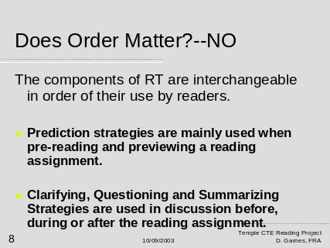  Facilitator Instructions:  - Display and Read the above slide.  - Explain:  The components of RT are interchangeable in order of their use by readers.  Prediction strategies are mainly used when pre-reading and previewing a reading assignment.  Clarifying, Questioning and Summarizing Strategies are used in discussion before, during or after the reading assignment. |  | Participant Instructions:  - Read slide 8 and note:  - This slide is for the teacher’s information that the order of the strategies are interchangeable when using the RT approach.  - Teacher’s may ask how do they prepare the students for using the RT approach. This will be explained in the next five slides.
Slide 9  How do teachers implement the RT Strategies?  Materials:  Facilitator Guidebook  For RT Workshop  RT Power point Presentation  Vocational /Technical Textbook or reading samples.  Facilitator Readings information for discussion of this slide taken from:  the short research brief: Reciprocal Teaching, pages 144-148, from Michael C. McKenna’s book:  Help for Struggling Readers: Strategies for Grades 3-8.  Handout 1-1 |  |  | 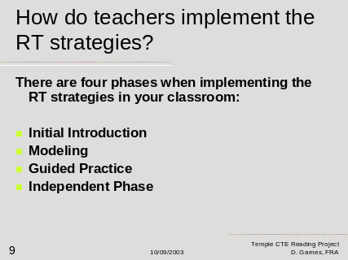  Facilitator Instructions:  - Display and Read the above slide.  - This slide is an organizational slide, which leads the workshop into implementing the four different strategies of Reciprocal Teaching.  - Explain to the group that each area: Initial introduction, Modeling, Guided Practice, and the Independent Phase will be discussed in the next four slides.  - Move onto the next slide for Initial Instruction information. |  | Participant Instructions:  - Read slide 9 and note:  Teacher’s may wish to write these four areas into their notes as each will be discussed in the following slides which focus on preparing the student for using Reciprocal Teaching Strategy in their reading.  Teachers may also note to their students that they are going to approach reading with more emphasis on understanding the text and their ability to use the following reading skills:  - Enact or recall what they already know about the topic  - Contribute to teacher led discussions by sharing their predictions.  - Ask questions about the reading  - Create summaries of what they have read.
Slide 10  Initial Introduction  Materials:  Facilitator Guidebook  For RT Workshop  RT Power point Presentation  Vocational /Technical Textbook or reading samples.  Facilitator Readings  information for discussion of this slide taken from:  the short research brief: Reciprocal Teaching, pages 144-148, from Michael C. McKenna’s book:  Help for Struggling Readers: Strategies for Grades 3-8.  Handout 1-1 |  |  | 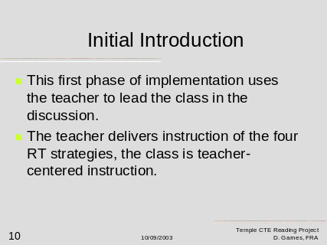  Facilitator Instructions:  - Display and Read the above slide.  - Explain: that the rationale for RT hinges on the concept of students providing support for one another.  - Explain: The teacher however plays a key role in the initial training of the students to use the RT strategies while they read. Take nothing for granted.  - Procedure: Carefully explain and define each of the four strategies are: predicting, clarifying, questioning, and summarizing. These are abstract terms so you may wish to share with your class each RT strategy checklist of reading activities, which you will receive during this workshop. |  | Participant Instructions:  - Read slide 10 and note the following:  - Some teachers cloaked the initial introduction phase of RT by slowly infusing the strategies into their reading lesson. This procedure seemed to work well in the pilot study.  - Other teachers discussed the RT Strategy Checklists with their students.  - Whichever method you choose, some technique of explaining what you what the students to do before, during and after they read must be established in your classroom.  - Modeling is the next phase of implementation.
Slide 11  Modeling  Materials:  Facilitator Guidebook  For RT Workshop  RT Power point Presentation  Vocational /Technical Textbook or reading samples.  Facilitator Readings  information for discussion of this slide taken from:  the short research brief: Reciprocal Teaching, pages 144-148, from Michael C. McKenna’s book:  Help for Struggling Readers: Strategies for Grades 3-8.  Handout 1-1 |  |  | 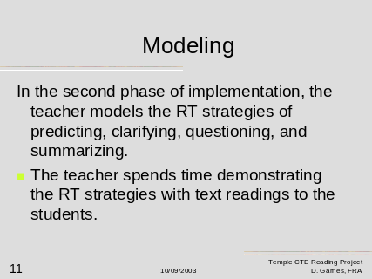  Facilitator Instructions:  - Display and Read the above slide.  - Distribute to the group Handout 1-1 Reciprocal Teaching. It will be used in your demonstration of modeling  - Demonstrate the four components of reciprocal teaching predict, clarify question and summarize.  - Predict: note: Headlines, subheads, arrangement of the article, diagrams, chart page 148.  - Clarify: difficult terminology, such as: (QAR) question-answer relationships.  - Question: What is RT and how do teachers prepare students for Reciprocal Teaching  - Summarize: Have the group read pages 144-145 and ask for volunteers to summarize the main points of the passage. |  | Participant Instructions:  - Read slide 11 and note:  - Modeling is an instructional technique, which will illustrate to the students how to use the RT strategies.  - Use Handout 1-1 to illustrate the modeling component of this workshop. Have the group silently read pages 144-145.  - Facilitator will demonstrate the four components of RT as indicated in column 2. Facilitator will allow ten minutes for this activity which includes discussing the summarization of the passage.  - Ask teachers for questions about modeling. Remind teachers that refining each component of RT will follow in this workshop.  - Proceed to Guided Practice, slide 12.
Slide 12  Guided Practice  Materials:  Facilitator Guidebook  For RT Workshop  RT Power point Presentation  Vocational /Technical Textbook or reading samples.  Facilitator Readings:  Refer to  Handout 1-1, page 145: Preparing students for Reciprocal Teaching |  |  | 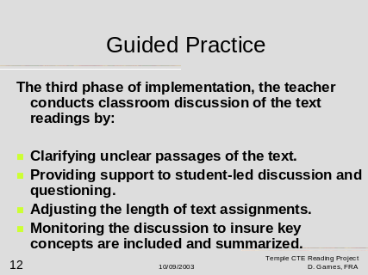  Facilitator Instructions:  - Display and Read the above slide.  - Explain: As new selections are introduced, gradually shift the responsibility for applying the strategies to the students.  - Call upon students in the course of the discussion to play an increasing role in the making of predictions, seeking clarification, asking questions, and creating summaries.  - Monitor the students’ efforts  - Provide feedback as needed. |  | Participant Instructions:  - Read slide 12 and note:  The third phase of implementation, the teacher conducts classroom discussion of the text readings by:  Clarifying unclear passages of the text.  Providing support to student-led discussion and questioning.  Adjusting the length of text assignments.  Monitoring the discussion to insure key concepts are included and summarized.  2. Continue to next slide.
Slide 13  Independent Phase  Materials:  Facilitator Guidebook  For RT Workshop  RT Power point Presentation  Vocational /Technical Textbook or reading samples.  Facilitator Readings: refer to Handout 1-1  Page 145-146  Conducting a Reciprocal Teaching Lesson |  |  | 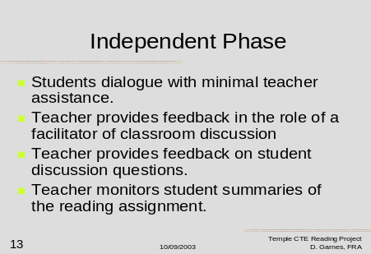  Facilitator Instructions:  - Display and Read the above slide.  - Explain: information presented on the slide.  - Add: Journal writing activities such as those presented later in this workshop will add to the independent phrase of student acquisition of the RT strategies. |  |  |  | Participant Instructions:  1. Read slide 13 and note:  In the independent phase, teachers should be observing these items:  - Students dialogue with minimal teacher assistance.  - Teacher provides feedback in the role of a facilitator of classroom discussion  - Teacher provides feedback on student discussion questions.  - Teacher monitors student summaries of the reading assignment.  2. Continue to the next slide.
Slide 14  What is the teacher’s role?  Materials:  Facilitator Guidebook  For RT Workshop  RT Power point Presentation  Vocational /Technical Textbook or reading samples.  Facilitator Readings: information for discussion of this slide taken from:  the short research brief: Reciprocal Teaching, pages 144-148, from Michael C. McKenna’s book:  Help for Struggling Readers: Strategies for Grades 3-8.  Handout 1-1 |  |  | 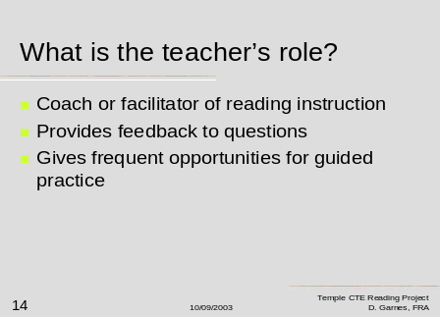  Facilitator Instructions:  - Display and Read the above slide.  - This is a summary slide of preparing students for Reciprocal Teaching.  3. Ask for any questions from the group at this point. |  | Participant Instructions:  - Read slide 14 and note:  - In summary What is the teacher’s role for preparing a student for Reciprocal Teaching?  - Coach or facilitator of reading instruction  - Provides feedback to questions  - Gives frequent opportunities for guided practice  3. Continue to the next slide.
Slide 15  What is Predicting?  Materials:  Facilitator Guidebook  For RT Workshop  RT Power point Presentation  Vocational /Technical Textbook or reading samples.  Facilitator Readings:  Handout 1-1 as reference material. |  |  | 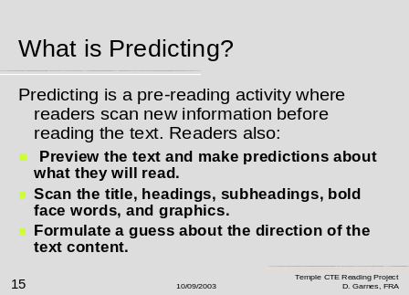  Facilitator Instructions:  - Display and Read the above slide.  - Explain that predictions should be used as before reading strategy, also additional information on slide 16.  3. Continue to the next slide for more information about the predicting strategy of RT. |  |  | Participant Instructions:  - Read slide 15 and note:  What is Predicting? Predicting is a pre-reading activity where readers scan new information before reading the text.  Readers also:  - Preview the text and make predictions about what they will read.  - Scan the title, headings, subheadings, bold face words, and graphics.  - Formulate a guess about the direction of the text content.  - Continue reading the next slide.
Slide 16  What is predicting?  Materials:  Facilitator Guidebook  For RT Workshop  RT Power point Presentation  Vocational /Technical Textbook or reading samples.  Facilitator Readings:  Refer to  Handout 1-1 as reference material. |  |  | 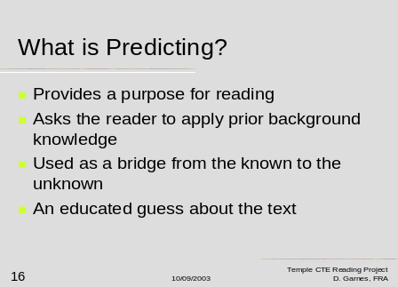  Facilitator Instructions:  - Display and Read the above slide.  - After discussing slides 15 and 16, conduct the following RT Workshop Activity: Take two minutes to locate and scan a reading passage in your content area text. After doing so, write two predictions about the passage, and then share your reading passage and predictions with your cluster group or workshop partner.  - Discuss how predicting would be useful with your students? |  | Participant Instructions:  1. Read slide 16 and note:  What is Predicting?  - Provides a purpose for reading  - Asks the reader to apply prior background knowledge  - Used as a bridge from the known to the unknown  - An educated guess about the text  - Conduct short prediction activity.  - Discuss how predicting would be useful with your students?  4. Continue to the next slide.
Slide 17  How do teacher’s implement predicting strategies?  Materials:  Facilitator Guidebook  For RT Workshop  RT Power point Presentation  Vocational /Technical Textbook or reading samples.  HANDOUT 17-1  Facilitator Readings:  Facilitators will need to distribute Handout 17-1: Are Readers Implementing Reciprocal Teaching Strategy A Quick Checklist: Are Readers Predicting? |  |  | 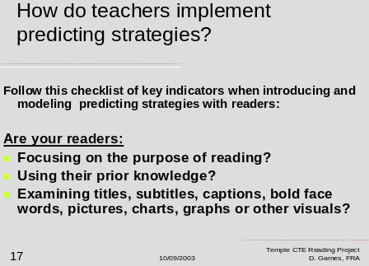  Facilitator Instructions:  - Display and Read the above slide.  - Distribute Handout 17-1  Are Readers Implementing Reciprocal Teaching Strategy A Quick Checklist: Are Readers Predicting?  3. Discuss this handout and suggest that teachers may wish to follow these 5 key areas when they instruct, model and use guided practice with their readers. |  | Participant Instructions:  - Read slide 17 and note  How do teachers implement predicting strategies?  Follow this checklist of key indicators when introducing and modeling predicting strategies with readers:  Are your readers:  - Focusing on the purpose of reading?  - Using their prior knowledge?  - Examining titles, subtitles, captions, boldface words, pictures, charts, graphs or other visuals?  - Making Predictions about key information they will learn  - Making a connection to the real-world applications from the reading?  2. Continue with the next slide.
Slide 18  How do teacher’s implement predicting strategies?  (A continuation of slide 17 information)  Materials:  Handout 18-1 The Prediction Journal  Facilitator Guidebook  For RT Workshop  RT Power point Presentation  Vocational /Technical Textbook or reading samples.  Facilitator Readings:  Facilitators should refer to Handout 18-1: The Prediction Journal for this slide. |  |  | 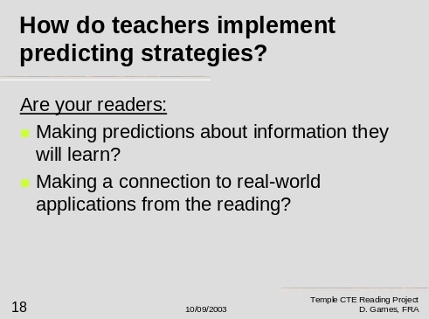  Facilitator Instructions:  - Display and Read the above slide.  - Distribute the Prediction Journal to all workshop participants.  - Discuss each question on the journal and mention:  Question 1—enacts prior knowledge  Question 2- students make a prediction or two.  Question 3-teachers suggest main concepts to focus upon in the passage  Question 4- students write a reading goal.  Question 5- students think about those reading strategies which may help them understand the passage  - Suggest that teachers use this journal as a writing activity with their struggling readers as a scaffold to support the instruction of making predictions from text and self monitor their reading. |  |  |  | Participant Instructions:  - Read slide 18 and note:  How do teachers implement predicting strategies?  Follow this checklist of key indicators when introducing and modeling predicting strategies with readers:  Are your readers:  - Focusing on the purpose of reading?  - Using their prior knowledge?  - Examining titles, subtitles, captions, boldface words, pictures, charts, graphs or other visuals?  - Making Predictions about key information they will learn  - Making a connection to the real-world applications from the reading?  2. Continue with the next slide.
Slide 19  What is Clarifying?  Materials:  Facilitator Guidebook  For RT Workshop  RT Power point Presentation  Vocational /Technical Textbook or reading samples.  Facilitator Readings:  Handout 1-1 as reference material. |  |  | 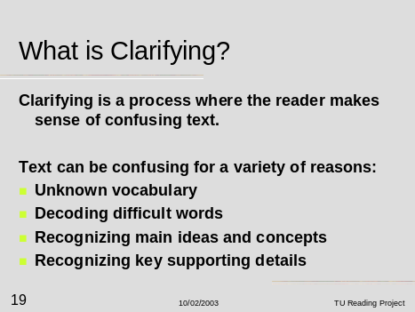  Facilitator Instructions:  - Display and Read the above slide  - Explain : Also mention these troublesome areas students may need clarification with content area textbooks:  - Trouble with text format  - Difficulty with diagrams, pictures, charts or other visuals  - Inability to read side notes or footnoted material  - Pace of reading is too fast  - Page numbers difficult to follow  - Unable to find or use a glossary, table of contents, or index  - Limited knowledge in reading a variety of text formats: textbook, newspaper, Internet article, trade manual. |  | Participant Instructions:  - Read Slide 19 and note:  Clarifying is a process where the reader makes sense of confusing text.  Text can be confusing for a variety of reasons:  - Unknown vocabulary  - Decoding difficult words  - Recognizing main ideas and concepts  - Recognizing key supporting details  These are additional troublesome areas students may need clarification with content area textbooks:  - Trouble with text format  - Difficulty with diagrams, pictures, charts or other visuals  - Inability to read side notes or footnoted material  - Pace of reading is too fast  - Page numbers difficult to follow  - Unable to find or use a glossary, table of contents, or index  - Limited knowledge in reading a variety of text formats: textbook, newspaper, Internet article, trade manual.
Slide 20  What is Clarifying?  Teacher’s Role  Materials:  Facilitator Guidebook  For RT Workshop  RT Power point Presentation  Vocational /Technical Textbook or reading samples.  Facilitator Readings:  Handout 22-1  Refer to this clarification checklist, which will be distributed to the group at slide 22. |  |  | 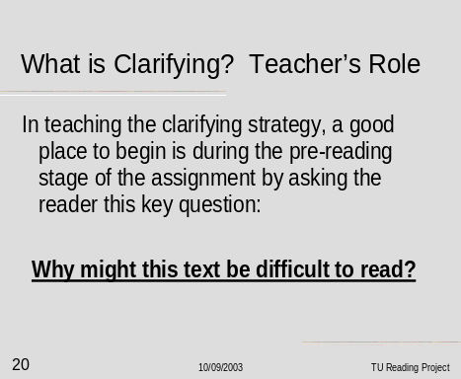  Facilitator Instructions:  - Display and Read the above slide.  - Explain this key question:  Why might this text passage be difficult to read?  Note: the teacher should use modeling with their instruction in the pre-reading phase of the reading assignment and specifically point out areas where a student may need to re-read, slow their pace of reading, or use decoding skills to understand troublesome vocabulary they encounter.  - Continue to Slide 21. |  | Participant Instructions:  - Read Slide 20 and note:  Why might this text be difficult to read?  In pre-reading use modeling to show the student BEFORE they read the passage any RED FLAG areas—i.e. areas where you, the teacher know they may have trouble in understanding the passage they are about to read.  These areas may include areas discussed in slide 19.  - Unknown vocabulary  - Decoding difficult words  - Recognizing main ideas and concepts  - Recognizing key supporting details  - Trouble with text format  - Difficulty with diagrams, pictures, charts or other visuals  - Inability to read side notes or footnoted material  - Pace of reading is too fast  - Page numbers difficult to follow  - Unable to find or use a glossary, table of contents, or index  - Limited knowledge in reading a variety of text formats: textbook, newspaper, Internet article, trade manual.
Slide 21  What is Clarifying?  Teacher’s Role  Materials:  Facilitator Guidebook  For RT Workshop  RT Power point Presentation  Vocational /Technical Textbook or reading samples.  Facilitator Readings:  Handout 22-1  Refer to this clarification checklist, which will be distributed to the group at slide 22. |  |  | 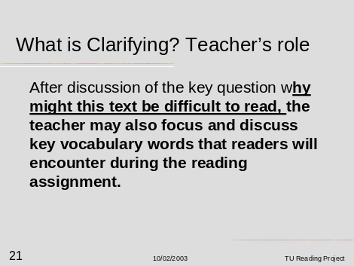  Facilitator Instructions:  - Display and Read the above slide.  - Suggest that teachers may wish to have students keep a personal glossary of troublesome vocabulary. They can then refer to this glossary list for review. This works especially well when students keep a list of vocabulary specific to their vocational area.  - Activity: Have the teachers scan a sample reading passage from their textbook and create a list of words that they would share with their students using the modeling approach to clarifying text.  - Share with open discussion from the workshop participants the troublesome vocabulary words teachers have identified from their passage. Discuss why it is important to clarify these words before a student reads the passage. |  | Participant Instructions:  Read Slide 21 and note the following:  - Teachers may wish to have students keep a personal glossary of troublesome vocabulary. The students can then refer to this glossary list for review when asked to recall the information. This works especially well when students keep a list of vocabulary specific to their vocational area.  - Discuss why it is important to clarify text vocabulary words before a student reads the passage. Possible responses are as follows:  - Increasing text understanding  - activating prior knowledge  - guiding the student to be aware of new terms they will encounter.  - Continue to slide 22.
Slide 22  What is Clarifying?  Student’s Role  Materials:  Facilitator Guidebook  For RT Workshop  RT Power point Presentation  Vocational /Technical Textbook or reading samples.  Facilitator Readings:  Handout 22-1  Are Students Clarifying? A Quick Checklist:  Readers use these strategies to make the text easier to understand before and during the reading process. |  |  | 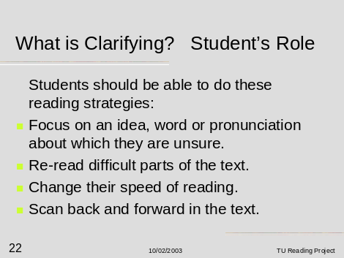  Facilitator Instructions:  - Display and Read the above slide.  - Distribute, Read and Discuss Handout 22-1 Are student’s clarifying?  - Explain that graphic organizers (checklist point # 5) can be in many forms such as Key questions, Outlining, or K-W-L strategies. More graphic organizer activities will be addressed in detail in the Scaffolding Instruction Workshop Facilitator’s Guidebook.  - Remind teachers to be aware of the RT Clarifying Strategies contained on the next two slides. |  | Participant Instructions:  - Read Slide 22 and note the following:  - Teachers should refer to Handout 22-1 for reminders on clarifying strategies.  - Graphic organizers (checklist point # 5) can be in many forms such as Key questions, Outlining, or K-W-L strategies. More graphic organizer activities will be addressed in detail in the Scaffolding Instruction Workshop #2.  4. Continue to Slide 23 and discuss the Discussion Journal. (Handout 23-1). The discussion journal can be used to help students clarify and organize ideas they are reading about in a text passage.
Slide 23  What is Clarifying?  Student’s Role, (a continuation of slide 22.)  Materials:  Facilitator Guidebook  For RT Workshop  RT Power point Presentation  Vocational /Technical Textbook or reading samples.  Facilitator Readings:  Handout 23-1:  Discussion Journal. |  |  | 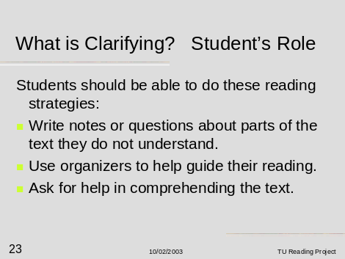  Facilitator Instructions:  - Display and Read the above slide.  - Distribute, Read and Discuss Handout 23-1 Discussion Journal.  - Explain: while the student reads the passage, it is important that students reflect on the following questions to monitor their own comprehension of the material, and students identify those areas of the passage where they are in need of clarification.  - Questions in this journal aid in the self-monitoring of the student’s reading process.  - Teacher may wish to use all or parts of this journal as a writing activity, which links to the reading passage. |  | Participant Instructions:  - Read slide 23 and note.  - Distribute, Read and Discuss Handout 23-1 Discussion Journal.  - Explain: while the student read the passage, it is important that they reflect on the following questions to monitor their own comprehension of the material, and to identify those areas of the passage where they are in need of clarification.  - Questions in this journal include:  - What are you predicting the main idea of the passage to be at this time?  - What are some ideas form the passage you have read about?  - What concepts are you trying to understand by reading this passage?  - Explain the reading strategies most helpful to you at this point in the reading.
Slide 24  Slides 24 and 25 introduce the RT Strategy of Questioning text.  What is Questioning?  Materials:  Facilitator Guidebook  For RT Workshop  RT Power point Presentation  Vocational /Technical Textbook or reading samples.  Facilitator Readings:  Refer to  Handout 1-1 Reciprocal Teaching for guidance in the Slides 24 and 25.  Also, facilitators may refer to Handout 28-1 the checklist for RT Questioning. |  |  | 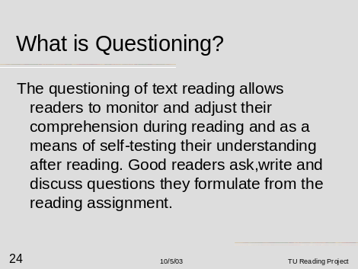  Facilitator Instructions:  - Display and Read the above slide.  - Explain that we, as teachers, ask questions to our students all the time. The questioning phase of RT Strategy reading asks the students to develop, ask, write answer, and discuss questions they formulate from the reading assignment.  3. Slide 25 continues with more information on: What is questioning? |  | Participant Instructions  - Read slide 24 and note:  The questioning of text reading allows readers to monitor and adjust their comprehension during reading and as a means of self-testing their understanding after reading.  Good readers ask, write and discuss questions they formulate from the reading assignment.
Slide 25  Slides 24 and 25 introduce the RT Strategy of Questioning text.  What is Questioning?  Materials:  Facilitator Guidebook  For RT Workshop  RT Power point Presentation  Vocational /Technical Textbook or reading samples.  Facilitator Readings:  Handout 25-1:  Post It note uses for RT.  Also, facilitators may refer to Handout 28-1 the Checklist for RT Questioning. Are Your Students Questioning |  |  | 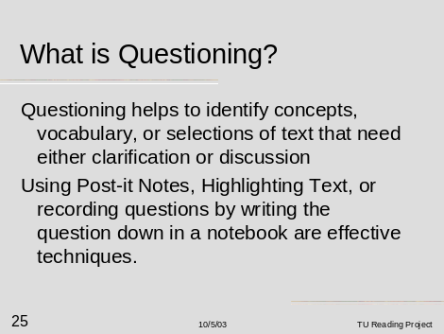  Facilitator Instructions:  1. Display and Read the above slide.  2. Explain:  - Questioning helps to identify concepts, vocabulary, or selections of text that need either clarification or discussion.  - Using Post-it Notes, Highlighting Text, or recording questions by writing the question down in a notebook are effective techniques.  3. Distribute and Explain Handout 25-1: Post It Note Uses for RT. |  | Participant Instructions:  1. Read slide 25 and note:  The questioning of text reading allows readers to monitor and adjust their comprehension during reading and as a means of self-testing their understanding after reading. (Slide 24)  Good readers ask, write and discuss questions they formulate from the reading assignment.(Slide 24)  - Questioning helps to identify concepts, vocabulary, or selections of text that need either clarification or discussion.  - Using Post-it Notes, Highlighting Text, or recording questions by writing the question down in a notebook are effective techniques.
Slide 26  What is Questioning: Teacher’s Role?  Materials:  Facilitator Guidebook  For RT Workshop  RT Power point Presentation  Vocational /Technical Textbook or reading samples.  Facilitator Readings:  Handout 1-1 |  |  | 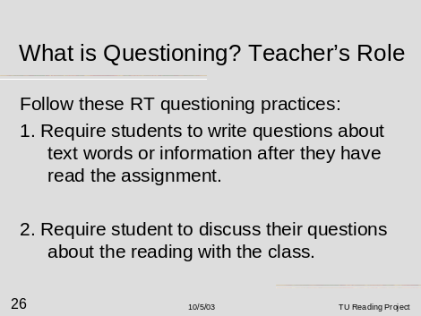  Facilitator Instructions:  - Display and Read the above slide.  2. Continue to Slide 27. |  | Participant Instructions:  Read slide 26 and note the following:  Follow these RT questioning practices:  - Require students to write questions about text words or information after they have read the assignment.  - Require student to discuss their questions about the reading with the class.
Slide 27  What is Questioning: Teacher’s Role?  Materials:  Facilitator Guidebook  For RT Workshop  RT Power point Presentation  Vocational /Technical Textbook or reading samples.  Facilitator Readings:  Handout 1-1 |  |  | 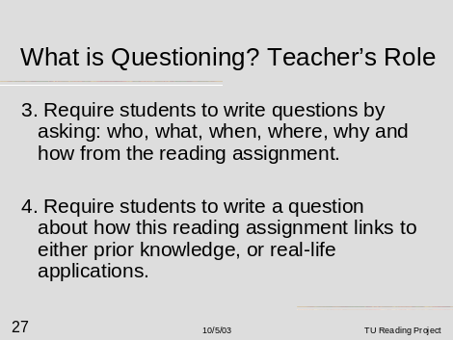  Facilitator Instructions:  1. Display and Read the above  slide.  2. Ask for any questions concerning slides 26 or 27.  2. Continue to Slides 28 and 29 to explain the student’s role in the RT Questioning Strategy. |  | Participant Instructions:  1. Read slide 27 and note:  When using the RT Questioning Strategy, teachers should:  1.Require students to write questions about text words or information after they have read the assignment. (Slide 26)  2.  Require student to discuss their questions about the reading with the class. (Slide 26)  3. Require students to write questions by asking: who, what, when, where, why and how from the reading assignment.  4. Require students to write a question about how this reading assignment links to either prior knowledge, or real-life applications.
Slide 28  What is Questioning?  Student’s Role  (Slides 28 and 29)  Materials:  Facilitator Guidebook  For RT Workshop  RT Power point Presentation  Vocational /Technical Textbook or reading samples.  Facilitator Readings:  Refer to  Handout 28-1:  Are Students Questioning: A Quick Checklist  For discussion of Slides 28 and 29. |  |  | 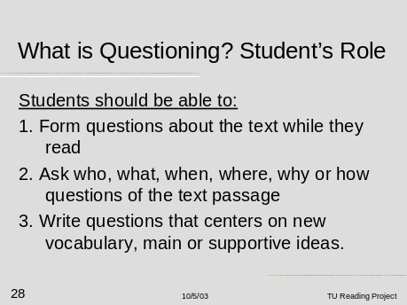  Facilitator Instructions:  - Display and Read the above slide.  - Distribute Handout 28-1: Are Students Questioning: A Quick Checklist for the workshop participant to follow as the facilitator discusses slides 28 and 29.  - Continue to Slide 29. |  | Participant Instructions:  1. Read slide 28 and note:  In using the RT Questioning Strategy, here is what the student should be able to do with respect to the reading process.  Students should be able to:  1. Form questions about the text while they read.  2. Ask who, what, when, where, why or how questions of the text passage.  3. Write questions that centers on new vocabulary, main or supportive ideas.
Slide 29  What is Questioning?  Student’s Role  (Slides 28 and 29)  Materials:  Facilitator Guidebook  For RT Workshop  RT Power point Presentation  Vocational /Technical Textbook or reading samples.  Facilitator Readings:  Refer to  Handout 28-1:  Are Students Questioning: A Quick Checklist  For discussion of Slides 28 and 29. |  |  | 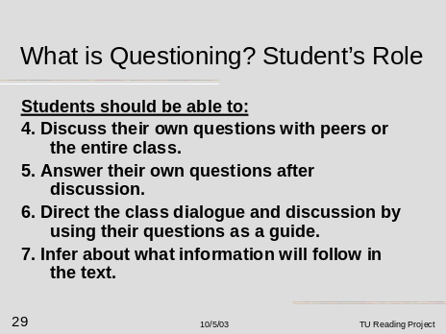  Facilitator Instructions:  - Display and Read the above slide.  - Discuss Handout 28-1: Are Students Questioning: A Quick Checklist. Remind teachers to share this checklist with their students.  - Continue to Slide 30. |  | Participant Instructions  1. Read slide 29 and note:  In using the RT Questioning Strategy, here is what the student should be able to do with respect to the reading process.  Students should be able to:  1. Form questions about the text while they read. (Slide 28)  2. Ask who, what, when, where, why or how questions of the text passage. (Slide 28)  3. Write questions that centers on new vocabulary, main or supportive ideas. (Slide 28)  4. Discuss their own questions with peers or the entire class.  5. Answer their own questions after discussion.  6. Direct the class dialogue and discussion by using their questions as a guide.  7. Infer about what information will follow in the text.
Slide 30  What is Summarizing?  ( a two part slide #30 and #31)  Materials:  Facilitator Guidebook  For RT Workshop  RT Power point Presentation  Vocational /Technical Textbook or reading samples.  Facilitator Readings:  Handout 1-1 for reference. |  |  | 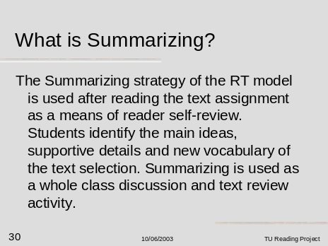  Facilitator Instructions:  - Display and Read the above slide.  - To continue the discussion of summarizing move to Slide 31. |  | Participant Instructions:  Read slide 30 and note the following:  - The Summarizing strategy of the RT model is used after reading the text assignment as a means of reader self-review.  - Students identify the main ideas, supportive details and new vocabulary of the text selection.  - Summarizing is used as a whole class discussion and text review activity.
Slide 31  Slides 31, 32, 33, 34 Refer to :  What is Summarizing?  Teacher’s Role  Materials:  Facilitator Guidebook  For RT Workshop  RT Power point Presentation  Vocational /Technical Textbook or reading samples.  Facilitator Readings:  Handout 1-1 |  |  | 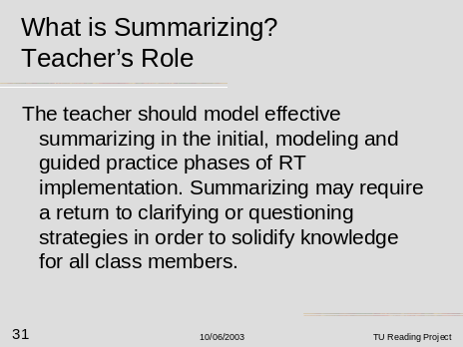  Facilitator Instructions  - Display and Read the above slide.  2. Continue to Slide 32. |  | Participant Instructions:  Read Slide 31 and note the following:  - The teacher should model effective summarizing in the initial, modeling and guided practice phases of RT implementation.  - Summarizing may require a return to clarifying or questioning strategies in order to solidify knowledge for all class members.
Slide 32  Slides 31, 32, 33, 34 Refer to :  What is Summarizing?  Teacher’s Role  Materials:  Facilitator Guidebook  For RT Workshop  RT Power point Presentation  Vocational /Technical Textbook or reading samples.  Facilitator Readings:  Handout 1-1 |  |  | 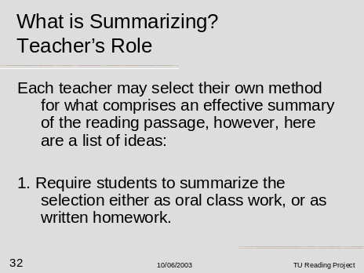  Facilitator Instructions:  - Display and Read the above slide  2. Continue to Slide 33. |  | Participant Instructions  Read Slide 32 and note the following:  Each teacher may select their own method for what comprises an effective summary of the reading passage, however, here are a list of ideas:  1. Require students to summarize the selection either as oral class work, or as written homework.
Slide 33  Slides 31, 32, 33, 34 Refer to :  What is Summarizing?  Teacher’s Role  Materials:  Facilitator Guidebook  For RT Workshop  RT Power point Presentation  Vocational /Technical Textbook or reading samples.  Facilitator Readings:  Handout 1-1 |  |  | 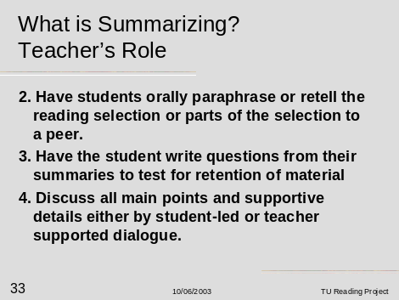  Facilitator Instructions:  - Display and Read the above slide  2. Continue to Slide 34. |  | Participant Instructions:  Read Slide 33 and note the following:  Each teacher may select their own method for what comprises an effective summary of the reading passage, however, here are a list of ideas:  2. Have students orally paraphrase or retell the reading selection or parts of the selection to a peer.  3. Have the student write questions from their summaries to test for retention of material.  4. Discuss all main points and supportive details either by student-led or teacher supported dialogue.
Slide 34  Slides 31, 32, 33, 34 Refer to :  What is Summarizing?  Teacher’s Role  Materials:  Facilitator Guidebook  For RT Workshop  RT Power point Presentation  Vocational /Technical Textbook or reading samples.  Facilitator Readings:  Handout 34-1:  The Reflection Journal |  | 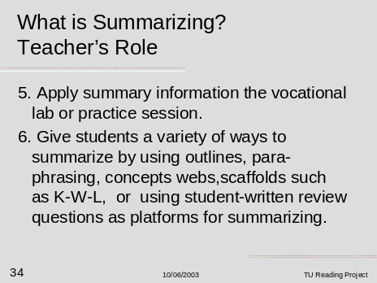  Facilitator Instructions  - Display and Read the above slide.  - Distribute and discuss Handout 34-1: The Reflection Journal.  - Handout 34-1 may be used as a summarizing activity with students after they have completed the reading passage: It consists of four questions which students briefly answer. Note that Question # 3 is key to summarizing main ideas and key points of the passage.  - The four questions are:  - What was the main idea of the passage?  - How did the main idea compare to your before reading prediction?  - Summarize at least three ideas form the passage you have read.  - What have you learned from this reading, which will help you in your career training? |  | Participant Instructions  Read slide 34 and note the following:  Each teacher may select their own method for what comprises an effective summary of the reading passage, however, here are a list of ideas:  5.Apply summary information the vocational lab or practice session.  6.Give students a variety of ways to summarize by using outlines, para phrasing, concepts webs, scaffolds such as K-W-L, or using student-written review questions as platforms for summarizing.  Note: The Reflection Journal is useful in getting students to summarize passages for increased comprehension and retention of the material.
Slide 35  Slides 35 and 36 refer to:  What is Summarizing? Student’s Role  Materials:  Facilitator Guidebook  For RT Workshop  RT Power point Presentation  Vocational /Technical Textbook or reading samples.  Facilitator Readings:  Handout 35-1: Are Readers Summarizing?  A Quick Checklist |  | 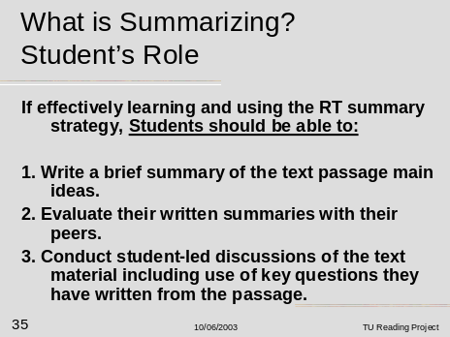  Facilitator Instructions:  - Display and Read the above slide.  2. Distribute and Discuss: Handout 35-1:  This handout lists specific summarizing activities that the student can be using to increase their ability to summarize text.  3. Continue to Slide 36. |  | Participant Instructions:  Read Slide 35 and note the following:  If effectively learning and using the RT summary strategy, Students should be able to:  1. Write a brief summary of the text passage main ideas.  2. Evaluate their written summaries with their peers.  3. Conduct student-led discussions of the text material including use of key questions they have written from the passage.
Slide 36  Slides 35 and 36 refer to:  What is Summarizing? Student’s Role  Materials:  Facilitator Guidebook  For RT Workshop  RT Power point Presentation  Vocational /Technical Textbook or reading samples.  Facilitator Readings:  Handout 35-1: Are Readers Summarizing?  A Quick Checklist |  | 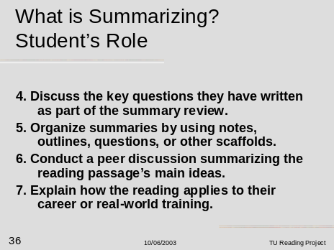  Facilitator Instructions:  - Display and Read the above slide.  2. Continue to Discuss:  Handout 35-1:  Are Readers Summarizing?  A Quick Checklist  3. Begin closure of the workshop by closing with slides 37, 38 Getting Started for Tecahers |  | Participant Instructions  Read Slide 36 and note the following:  If effectively learning and using the RT summary strategy, Students should be able to:  4. Discuss the key questions they have written as part of the summary review.  5. Organize summaries by using notes, outlines, questions, or other scaffolds.  6. Conduct a peer discussion summarizing the reading passage’s main ideas.  7. Explain how the reading applies to their career or real-world training.
Slide 37  Getting Started For Teachers  Materials:  Facilitator Guidebook  For RT Workshop  RT Power point Presentation  Facilitator Readings:  Handout 1-1 |  | 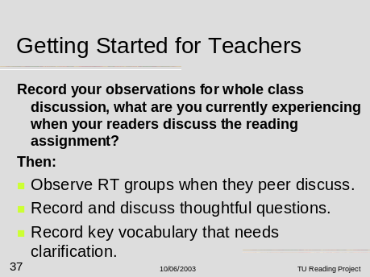  Facilitator Instructions:  - Display and Read the above slide.  - Slides 37 and 38 give the workshop participant some items to observe while using RT in their classrooms.  - Continue to slide 38. |  | Participant Instructions  Read slide 37 and note the following:  Record your observations for whole class discussion, what are you currently experiencing when your readers discuss the reading assignment?  Then:  - Observe RT groups when they peer discuss.  - Record and discuss thoughtful questions.  - Record key vocabulary that needs clarification.
Slide 38  Getting Started For Teachers  Materials:  Facilitator Guidebook  For RT Workshop  RT Power point Presentation  Facilitator Readings:  Handout 1-1 |  | 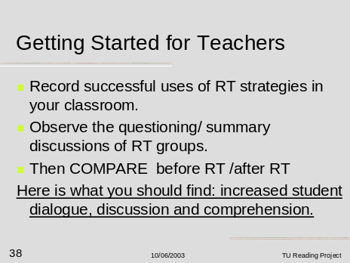  Facilitator Instructions:  1. Display and Read the above slide  - Slides 37 and 38 give the workshop participant some items to observe while using RT in their classrooms.  3. Continue to slides 39-40, workshop ending. |  | Participant Instructions:  Read slide 37 and note the following:  Record your observations for whole class discussion, what are you currently experiencing when your readers discuss the reading assignment?  Then:  - Record successful uses of RT strategies in your classroom.  - Observe the questioning/ summary discussions of RT groups.  Then COMPARE before RT /after RT. Here is what you should find: increased student dialogue, discussion and comprehension.
Slide 39  Closing Slide:  Reciprocal Teaching  Materials:  Facilitator Guidebook  For RT Workshop  RT Power point Presentation  Facilitator Readings:  Handout 39-1  Refer to the  Helping Conference Guide sheets for key questions that the site facilitator may use when conducting the helping conference. |  | 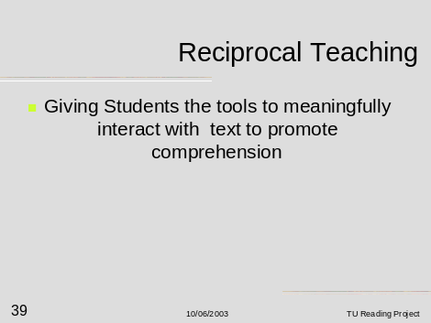  Facilitator Instructions:  - Display and Read the above slide.  - Ask for questions; if possible discuss how the facilitator will meet with teachers to conduct supportive follow-up coaching sessions by using the helping conference. Refer to Handout 39-1.  - Make note to the group how the site facilitator will use the helping conference to aid in the implementation of the RT strategies discussed in this initial workshop. |  | Participant Instructions  Read slide 39 and note:  Reciprocal Teaching:  Giving Students the tools to meaningfully interact with text to promote comprehension.
Slide 40  Credits Slide:  References used in the workshop  Materials:  None  Facilitator Readings:  Refer to the center column of this page for further readings. |  | 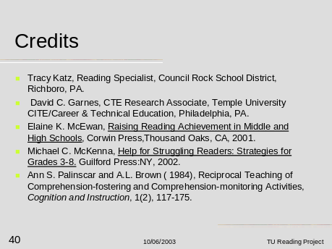  Facilitator Instructions  For further information on Reciprocal Teaching reading strategy, facilitators may refer to:  Elaine K. McEwan, Raising Reading Achievement in Middle and High Schools, Corwin Press, Thousand Oaks, CA, 2001.  Michael C. McKenna, Help for Struggling Readers: Strategies for Grades 3-8. Guilford Press: NY, 2002.  Ann S. Palinscar and A.L. Brown  (1984), Reciprocal Teaching of Comprehension-fostering and Comprehension-monitoring Activities, Cognition and Instruction, 1(2), 117-175. |  | Participant Instructions  Note: these references used in the preparation of materials for this workshop:  Elaine K. McEwan, Raising Reading Achievement in Middle and High Schools, Corwin Press, Thousand Oaks, CA, 2001.  Michael C. McKenna, Help for Struggling Readers: Strategies for Grades 3-8. Guilford Pressing, 2002.  Ann S. Palinscar and A.L. Brown  (1984), Reciprocal Teaching of Comprehension-fostering and Comprehension-monitoring Activities, Cognition and Instruction, 1(2), 117-175.

Reciprocal Teaching Workshop Handouts

All handouts in this section of the guidebook should be duplicated as part of conducting the Reciprocal Teaching Workshop
- Handout 1-1 is provided to each site facilitator and should be read by the facilitator before conducting the RT Workshop.

- Handout 2-1: The Strategic Reader

- Handout 17-1:Are Readers Predicting: A Quick Checklist

- Handout 18-1: Prediction Journal

- Handout 22-1: Are Readers Clarifying: A Quick Checklist

- Handout 23-1: Discussion Journal

- Handout 25-1: Post-It Note Uses

- Handout 28-1: Are Readers Questioning: A Quick Checklist

- Handout 34-1: Reflection Journal

- Handout 35-1: Are Readers Summarizing: A Quick Checklist

- Handout 39-1: Helping Conference Discussion Guide

Handout 2-1 Reciprocal Teaching Workshop

The Strategic Reader Gains Meaning by:

Before Reading:

- Determining Purpose
- Preview and Predict
- Activiates Prior Knowledge
- Asks Questions

During Reading:

- Develops Sensory Images: Visual and Auditory
- Infer
- Self Question
- Monitors and Adjusts Comprehension
- Rereads
- Look up information
- Changes speed
- Looks back or forward

After Reading:

- Paraphrase, Retell
- Summarize
- Synthesize
- Organize Graphically
- Evaluates ideas
- Generates Questions to test memory

Source: McEwan, E.K. Raising Reading Achievement in Middle and High School: 5 Simple-To-Follow Strategies for Principals, 2001: Corwin Press, Inc.

Handout 17-1 Reciprocal Teaching Workshop

Are Readers Implementing Reciprocal Teaching Strategy?

-A Quick Checklist-

Are Readers Predicting? Readers focus on the familiar information and scan new information before reading.

Are your students:

- Focusing on the purpose of the reading?

- Using prior knowledge?

- Examining titles, subtitles, and visual clues?

- Making predictions about information they will learn?

- Making a connection to real-world applications of the text?

Handout 18-1 Reciprocal Teaching Workshop

Prediction Journal (before reading)

Name _____________________ Date _______________

Before reading the passage, answer the following questions:

- What are some of the things you already know about the passage?

- What are some predictions about the passage?

- What concepts are you trying to understand by reading this passage?

4. What do you hope to learn by reading this passage?

- What reading strategies might you use as you read the passage to help you understand?

Handout 22-1 Reciprocal Teaching Workshop

Are Readers Implementing Reciprocal Teaching Strategy?

-A Quick Checklist-

Are Readers Clarifying? Readers use these strategies to make the text easier to understand before and during reading.

Are your students:

- Focusing on an idea, word, or pronunciation about which they are unsure?

- Re-reading difficult segments of the text?

- Scanning back and forward in the text?

- Changing their speed of reading?

- Using graphic organizers or notes to help outline and guide reading?

- Asking for help in comprehending the text from their peers and the teacher?

Handout 23-1 Reciprocal Teaching Workshop

Discussion Journal (during reading)

Name _____________________Date _______________

While reading the passage, reflect on your progress,
and answer the following questions:

- What are you predicting the main idea of the passage to be at this time?

2. What are some ideas from the passage you have read about?

3.What concepts are you trying to understand by reading this passage?

- Explain the reading strategies most helpful up to this point of the reading.

Handout 25-1 Reciprocal Teaching Workshop

POST-IT NOTE USES

For Reciprocal Teaching

This size note can be used for vocabulary
development, marking unknown words,
or identifying troublesome words.

This size note can be used for outlining, note-taking or

This size note can be used for recording questions. recording information.

This size note can be used for marking sentence, paragraphs or pages.

Center for Professional Development

In Career and Technical Education.

Temple University Reading Project

This size note can be used for writing summaries
paraphrasing text main ideas.

Handout 28-1 Reciprocal Teaching Workshop

Are Readers Implementing Reciprocal Teaching Strategy?

-A Quick Checklist-

Are Readers Questioning? Readers monitor and adjust comprehension during the reading process as a means of self-testing during and after reading.

Are your students:

- Forming questions about the text while they read?

- Forming self-questions by asking who, what, when, where, why, and how of the text?

- Inferring about what information will follow in the text?

- Forming question stems linking text information to real-life application?

Handout 34-1 Reciprocal Teaching Workshop

Reflection Journal (after reading)

Name _____________________ Date _______________

After reading the passage, reflect on your progress,
and answer the following questions:

- What was the main idea of the passage?

2. How did the main idea compare to your before reading prediction?

- Summarize at least three ideas from the passage you have read?

4. What have you learned from this reading which will help you in your career training?

Handout 35-1 Reciprocal Teaching Workshop

Are Readers Implementing Reciprocal Teaching Strategy?

-A Quick Checklist-

Are Readers Summarizing? Readers use summarizing strategies after reading as a means of self-review by identifying the most important points of the text selection.

Are your students:

- Orally paraphrasing or retelling the reading selection to peers?

- Applying information in the reading selection to a vocational practice in the lab?

- Summarizing the text selection as class work and/or homework?

- Generating questions from their summaries to test for retention?

- Writing summaries of what they read?

- Including important main points and ideas in the summaries?

- Organizing summaries by use of outlines, webs, or mapping?

- Evaluating their ideas with their peers?

Handout 39-1 Reciprocal Teaching Workshop

Helping Conference Discussion Guide

Date of visit____________________ School Site_________________________
Teacher visited__________________ Vocational Cluster Area_______________

1. How can I help you with the implementation of the reading strategy?

2. Which reading strategy(ies) was/were used this week in your classroom instruction?

3. Describe the strategy(ies) and how they worked in terms of:
a. Student reception/reaction

b. Text Content- appropriateness

c. Integration into existing curriculum

d. Teacher perceptions (reactions)

4. Describe any difficulties you experienced when delivering the reading strategy(ies)?

a. Reciprocal Teaching

b. Scaffolding

c. Journaling

5. Describe any successes you are observing with your students as you implement these reading strategies?

6. Please provide examples of questions your students ask as they are predicting, clarifying, and summarizing what they have read?

Questions #7 and #8 are to be asked after the second and third in-service training seminars-

7. Describe scaffolding activities you are using with the readings? Why was the specific scaffold selected?

8. Describe the journaling activities your students are writing this week.

9. What additional thoughts or observations do you have this week in terms of the reading project?

